CS 255 System Design Document
DriverPass System
This document presents the proposed technical design for the DriverPass system. The design is based on the Project One business requirements and the DriverPass interview. The system will provide secure, cloud-based access to registration, training packages, driving lesson scheduling, online practice exams, progress tracking, reporting, and account management.

UML Diagrams

UML Use Case Diagram
The case model identifies Customer, Secretary, Instructor, IT Administrator, Management, Payment, and the DMV as actors or external participants. The primary interactions include customer registration, authentication, package purchase, lesson scheduling, practice exams, progress tracking, instructor notes, user and package administration, reporting/auditing, and DMV content synchronization. These interactions reflect the requirement that customers and office staff can schedule lessons and that different employees have different permissions.
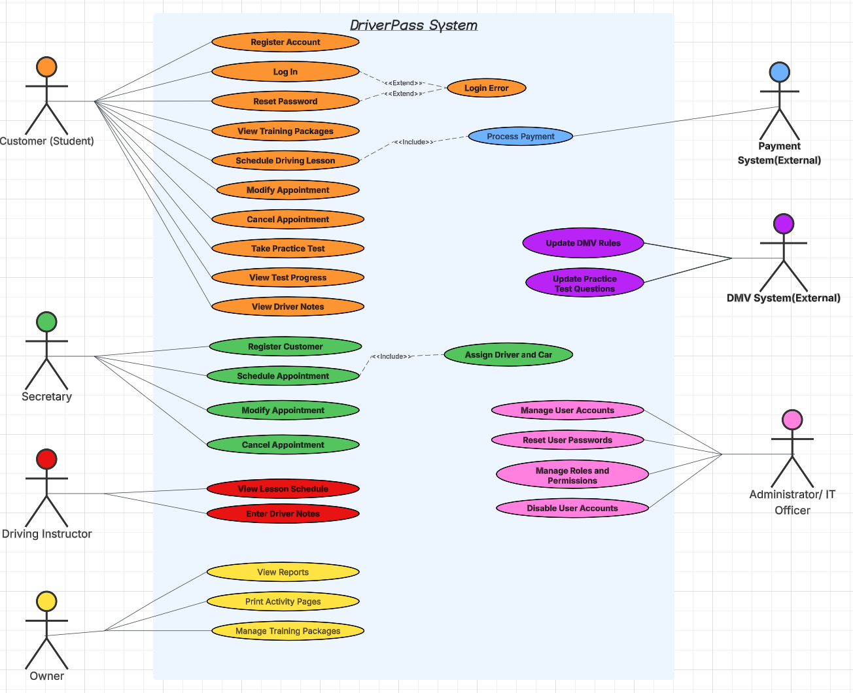

UML Activity Diagrams
The two selected use cases are scheduling a driving lesson and taking a practice exam.
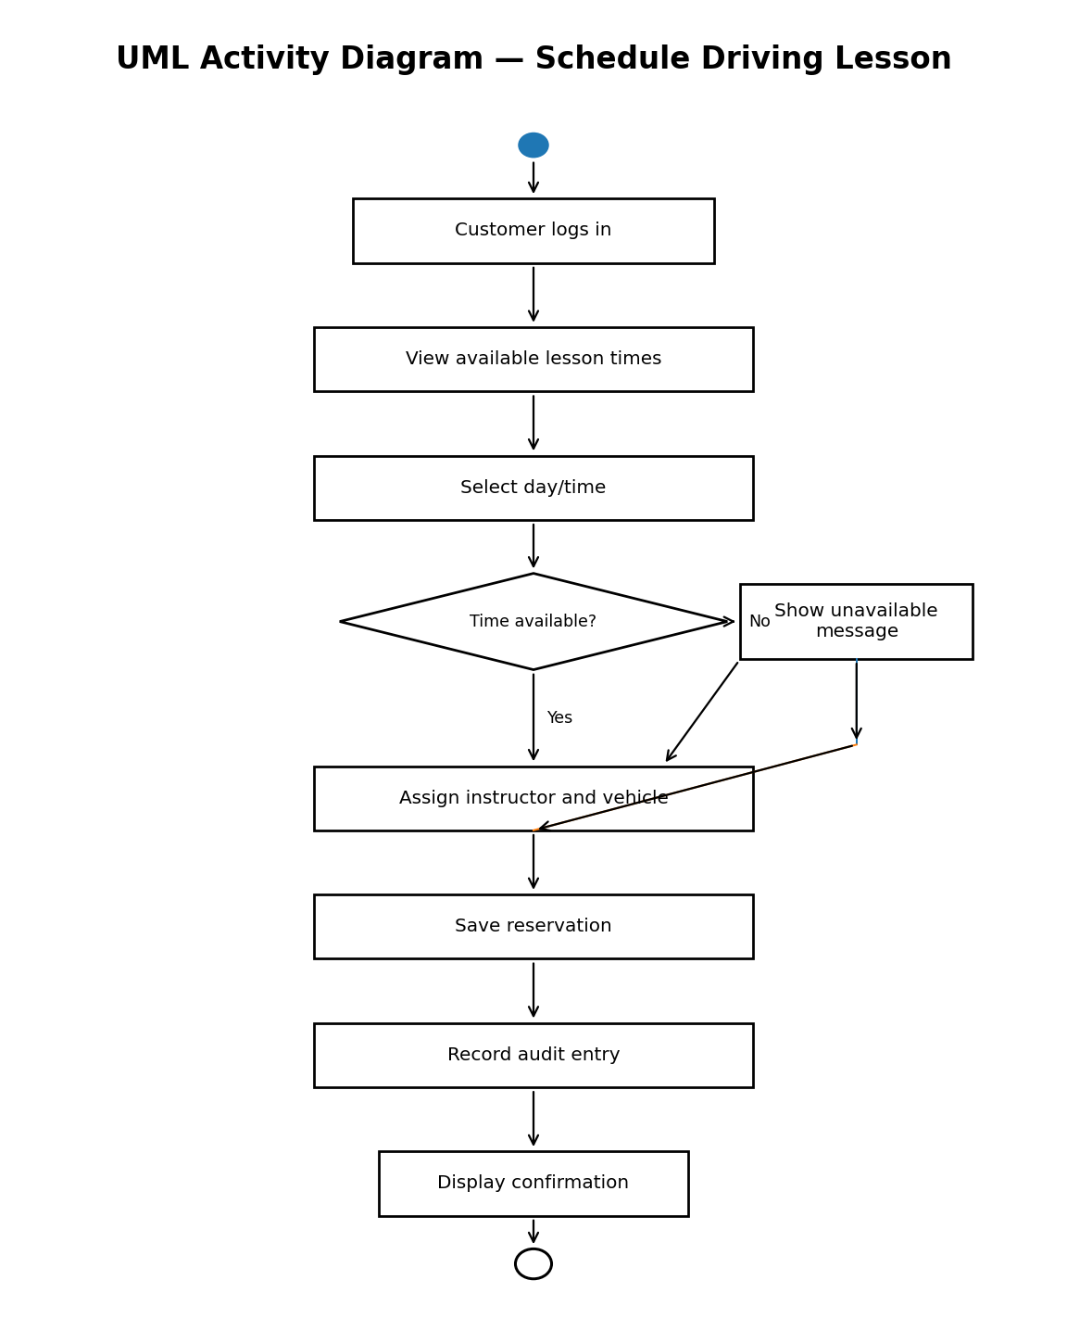
Figure 2. Activity flow for scheduling a driving lesson.
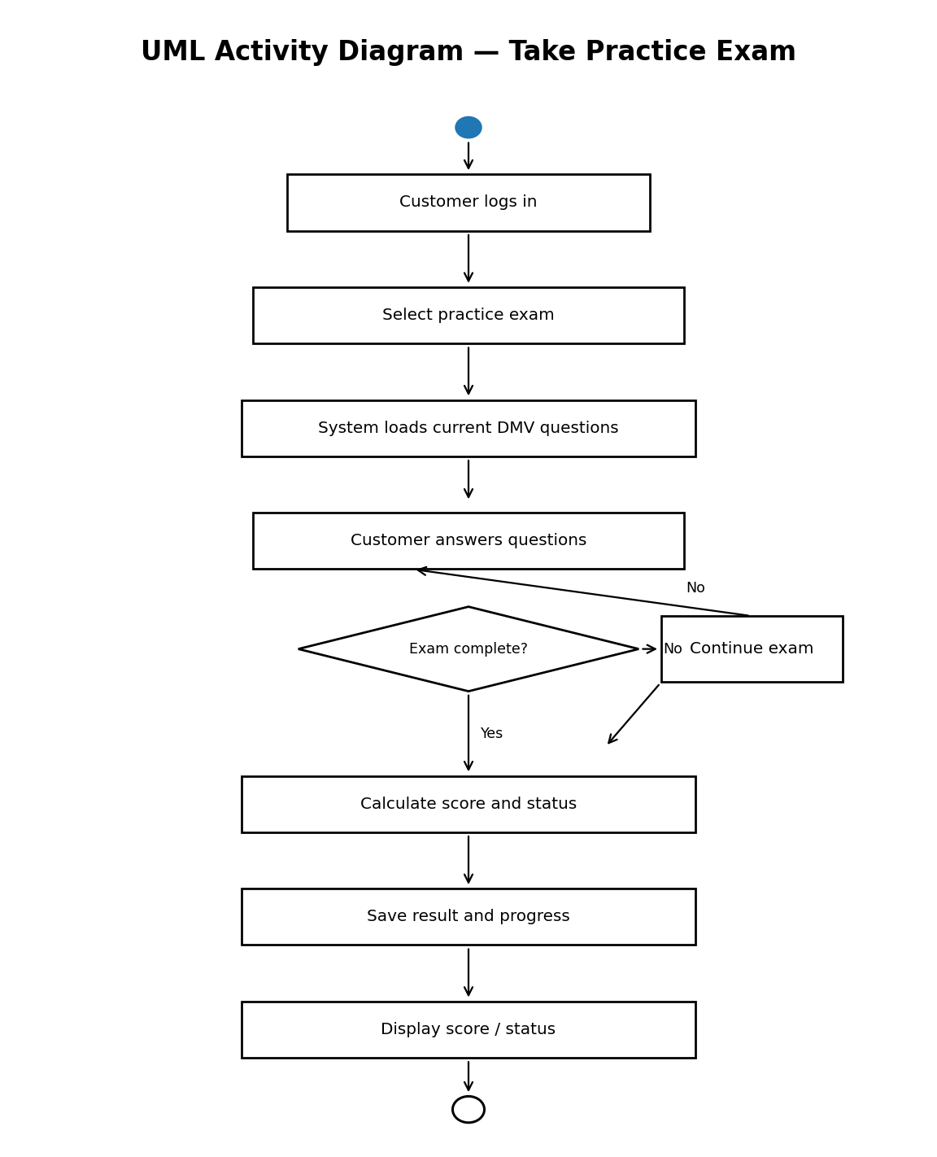
Figure 3. Activity flow for completing a practice exam.

UML Sequence Diagram
The sequence diagram expands the Schedule Driving Lesson use case. It shows the customer interacting with the web interface, scheduling service, and database. The flow includes authentication, availability lookup, selection of a lesson time, reservation creation, audit logging, and confirmation.
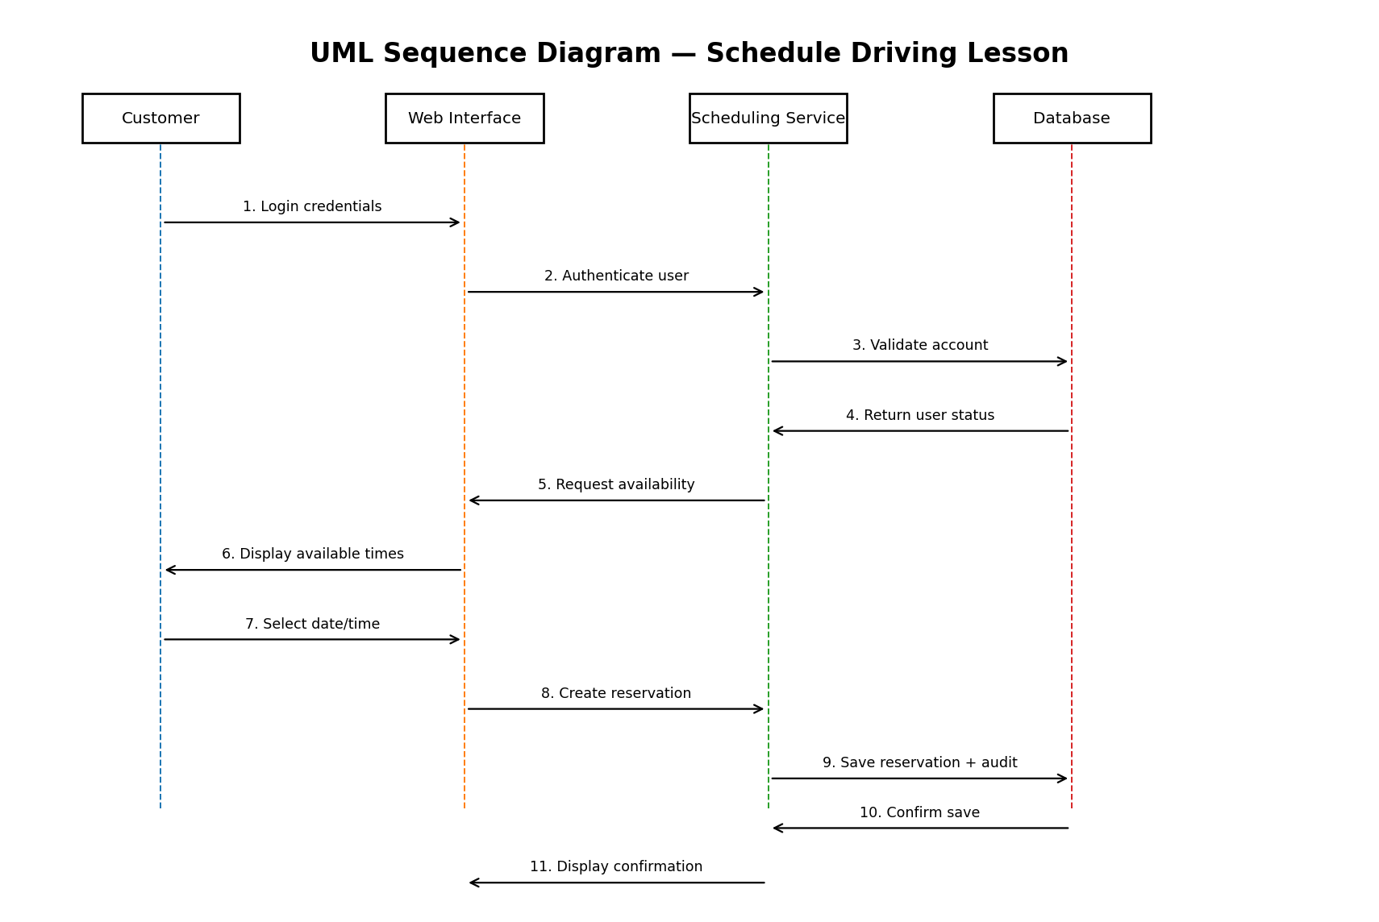

UML Class Diagram
The class model represents the major data objects needed by the system. Customer and employee information is separated from scheduling, training packages, vehicles, practice exams, exam results, audit records, and DMV updates. Attributes are included because the assignment does not require methods.
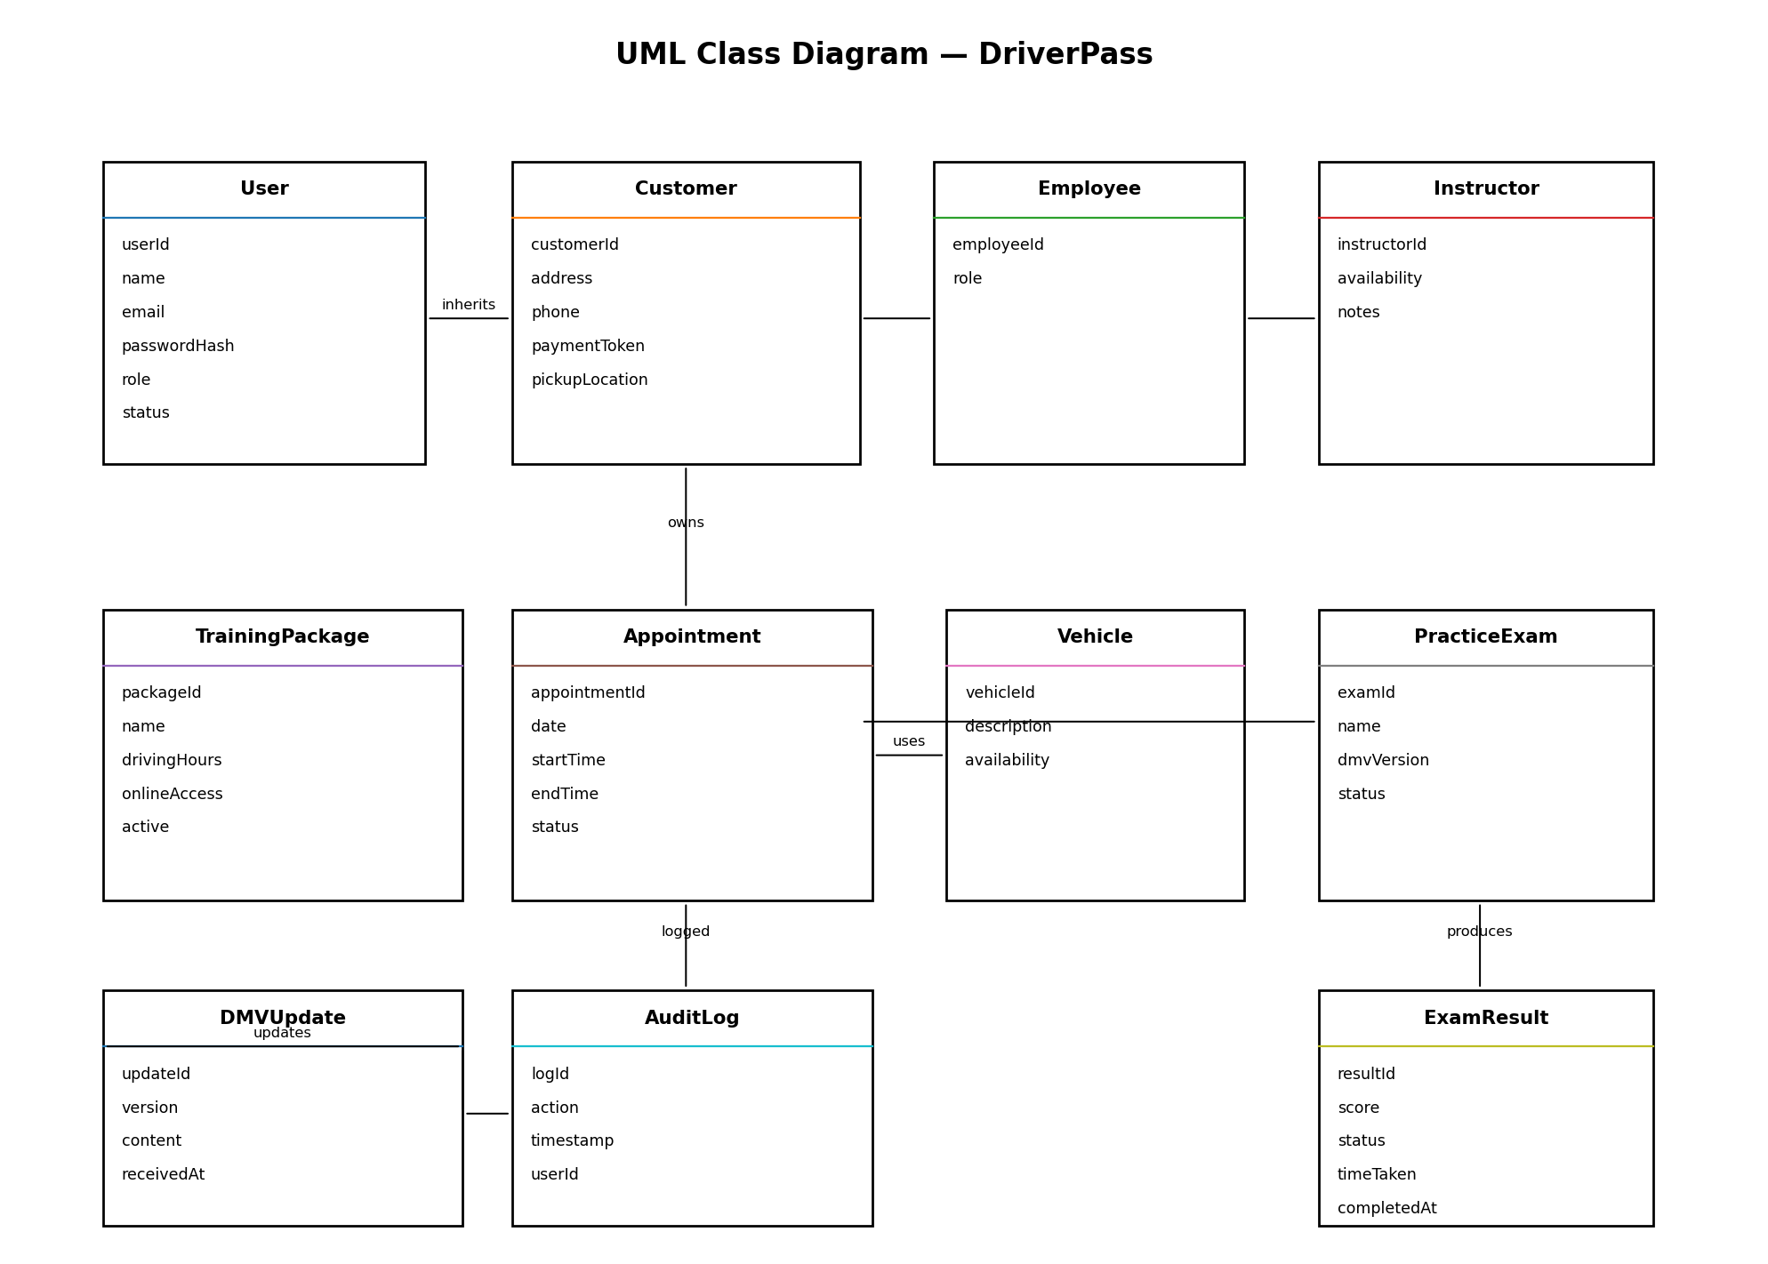

Technical Requirements
The technical requirements are derived from the Project One business requirements. DriverPass requires a web-based, cloud-hosted system with a relational database, responsive browser access, role-based permissions, secure communications, audit logging, and support for DMV content updates.

Hardware Requirements
- Cloud-hosted application and database infrastructure with sufficient capacity for concurrent customer and employee sessions.
- Server-side storage for customer records, appointments, training data, practice-test results, instructor notes, and audit logs.
- Backup and disaster-recovery infrastructure supplied by the cloud provider.
- Customer and employee devices may include desktop computers, laptops, tablets, and mobile devices with a modern web browser.

Software Requirements
- A responsive web application accessible through modern browsers on Windows, macOS, Linux, Android, and iOS.
- A relational database management system for persistent storage and transactional data.
- Server-side application/business-logic components for authentication, scheduling, package management, reporting, and role enforcement.
- Secure password-management and account-recovery functionality.
- Integration capability for DMV updates and a third-party payment processor.

Tools and Development Requirements
- Lucidchart or an equivalent CASE/UML tool for maintaining use case, activity, sequence, and class diagrams.
- A source-code repository and development environment for application development and version control.
- Testing tools for functional, security, browser-compatibility, and integration testing.
- Export capability for reports and selected information in formats that can be used with spreadsheet software such as Excel.

Infrastructure and Security Requirements
- Cloud hosting with HTTPS/TLS for all client-server communications.
- Role-based access control for customers, secretaries, instructors, IT administrators, and management.
- Account lockout after repeated failed login attempts and secure password-reset functionality.
- Audit logging for reservations, cancellations, modifications, and other critical actions, including timestamps and user identification.
- Automated backups and disaster recovery managed through the cloud environment.
- Monitoring and notification for system errors and failed DMV update operations.

Data and Integration Requirements
- The database must maintain unique customer records and securely store contact and payment information.
- Appointment records must associate a customer with a lesson time, instructor, and vehicle.
- Practice-test records must retain test name, time taken, score, and status such as not taken, in progress, failed, or passed.
- Instructor records must retain lesson times and instructor comments.
- The system must receive DMV rules, policies, and sample-question updates and notify administrators when updates are received.

Design Rationale
The proposed design supports the client's stated goal of operating the business through a web-based cloud system while minimizing technical administration. Customers can register, purchase a package, schedule or change lessons, and complete practice exams. Secretaries can register customers and manage appointments. Instructors can access assigned lesson information and record comments. IT administrators can manage accounts and permissions, while management can use reports and audit information. The design also allows packages to be enabled or disabled without requiring the initial release to provide a nontechnical package-module creation tool.
The design preserves the client's security and accountability requirements by using role-based access, encrypted communications, password recovery, account lockout, and audit logging. It also supports the requirement that the system remain current by providing a DMV update integration and administrator notifications.

Source Basis
The project template requires completing the UML diagrams and technical requirements in the system design document. The Project One requirements identify a secure cloud-based DriverPass system, responsive browser access, role-based access, a relational database, scheduling, practice exams, reporting, audit trails, and DMV synchronization. The DriverPass interview further specifies two-hour driving sessions, instructor/vehicle assignment, three training packages, customer registration information, online appointment changes, password reset, DMV update notifications, and the requested dashboard information.

